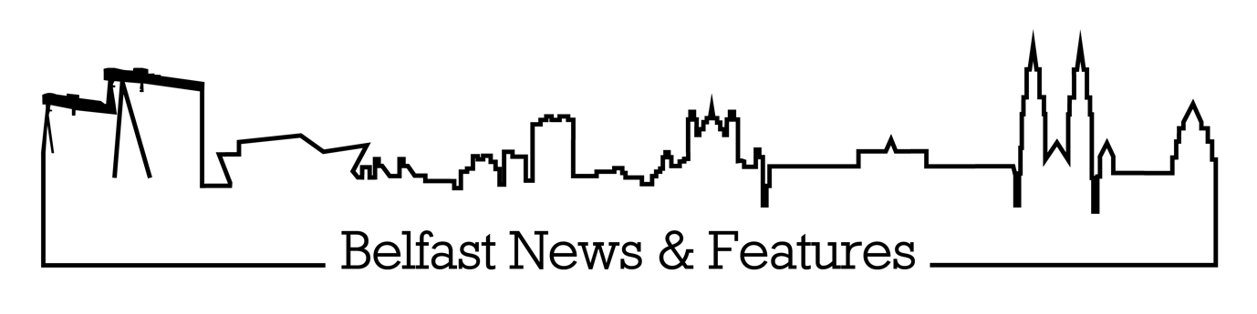

**BELFAST NEWS & FEATURES PRIVACY POLICY**

Effective 16/04/2018

**What to expect here:**

This privacy policy applies to the workings of Belfast News & Features Ltd, it’s director and journalist Jade Beecroft, any correspondence with the company via email, social media, telephone or face-to-face meeting, and the website [www.belfastnewsandfeatures.com](http://www.belfastnewsandfeatures.com). It describes how Belfast News & Features collects, uses, shares and secures any personal information you provide. It also covers your choices regarding use, access and correction of your personal information.

**Registration:**

Belfast News and Features Ltd is registered with the Information Commissioners Office, certificate ZA338023, and information on the company can be found on the ICO’s Public Register of Data Controllers via this link: <https://ico.org.uk/about-the-ico/what-we-do/register-of-data-controllers>

**What we do:**

Belfast News & Features Ltd is a small agency, based in Northern Ireland, working in the field of journalism and the media. It’s director and journalist Jade Beecroft is responsible for gathering stories, and supplying news, features and photos to a range of local and national magazines, newspapers and news websites. This involves both receiving and processing personal data, and transferring it to third parties. Belfast News & Features is therefore subject to UK data protection laws. Under certain circumstances, Belfast News & Features may be required to provide data in response to lawful requests by public authorities; for example, in the event of a court case or libel hearing.

Belfast News & Features Ltd also has access to media court and inquest lists, and is bound by legal reporting restrictions regarding the use of that data.

**What type of personal information is collected?**

In order to tell stories, Jade Beecroft will gain consent to collect some of the following information via interviews (both face-to-face and telephone), emails and social media correspondence:

* Personal details, including name, age, occupation, date of birth, family details and information about children.
* Contact information, such as postal and email addresses, telephone numbers and social media contacts.
* Background information, including education, employment history and interests.
* Business information if the case study is being interviewed in their professional capacity.
* Medical information, including details of illnesses or conditions relevant to the story, treatments and time spent in hospital.
* Other information specific to the particular story being researched.
* In the event that a case study payment is handled by Belfast News & Features Ltd, banking information will be taken for BACS payments.

**How is this information used?**

Data collected by Belfast News & Features is used for journalistic purposes and may be published in a wide range of newspapers, magazines and online. It is usual for Jade Beecroft to gain consent from case studies before stories are published; and to give anyone named a ‘right of reply’ – especially where allegations are made.

This may vary in the event of reporting from court cases, inquests or other public hearings, or where publication is in the public interest.

**How is information shared?**

Belfast News & Features Ltd is not, itself, a publisher. Rather, Jade Beecroft works on commission for other publishers (newspapers, websites and magazines).

In order to gain commissions, personal information is shared with commissioning editors at various publications. This is only done after consent has been gained from the case study, and they are made aware of exactly how their information and photographs will be shared. It is Belfast News & Features policy NOT to share any contact details during initial enquiries. This is only done once a commission as been secured, with the case study’s full consent, and often after a contract has been signed.

In certain situations Belfast News & Features Ltd may also be required to share information in response to lawful requests from public bodies such as the police and court services.

**Is information kept securely?**

The security of personal information is of paramount importance. Belfast News & Features Ltd keeps personal information securely in a number of ways. There are:

* Electronically – password protected. This may include emails, diary entries, photographs and written copy.
* Hard copies – kept in a secure office. This includes copies of contracts and invoices.
* In a journalist’s notebook – dated and in shorthand. As is typical for the industry, most interviews are recorded in this way.

Jade Beecroft is the only person who has full access to all these records.

**How long is data kept?**

That depends on whether or not a story has been published.

Once a story has been published, journalists are legally required to keep any interview notes or research relating to that story for at least a year, in case it ever becomes the subject of a libel or other legal hearing, when the notes will be required by the court as evidence. It has become industry practice to keep this evidence ­– especially notebooks – for much longer as cases of libel are brought further down the line. Many journalists now make a habit of keeping their full notebooks for five years, and Belfast News & Features Ltd follows this industry norm.

In the event that personal details are taken but a story does not result, this data is deleted off all Belfast News & Features Ltd electronic systems after one year. Hard copies are also shredded. Notepad interviews may remain for longer due to the practice of keeping full notepads for five years, outlined above. Basic contact details may also be retained, as is usual in the industry for journalists to maintain a ‘contacts book’ or diary.

**Accessing and deleting your data:**

Belfast News & Features Ltd is happy to provide you with details of any information the company holds about you upon request. You many also correct or update any information held. All such requests will be dealt with speedily; normally within 14 working days.

In the event that you have had contact with Jade Beecroft, but a story has not been published as a result, the company will be happy to destroy any information held about you upon request.

However, in the event that contact with Belfast News & Features Ltd has resulted in a story about you being published, the firm is required to keep your details on file as outlined above.

**Who oversees this?**

Director and journalist Jade Beecroft is responsible for the security of any data provided and stored by Belfast News & Features Ltd. Any queries should be addressed to [jadebeecroft@belfastnewsandfeatures.com](mailto:jadebeecroft@belfastnewsandfeatures.com). You can also reach her by calling 02890 296168.